How to generate an Invoice

1. Create an order (Ex-7908)

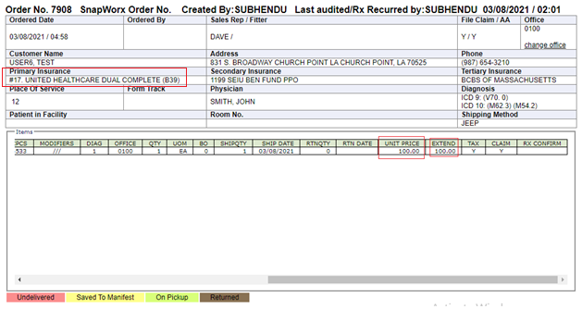

1. Check the order amount and Insurance Company
2. Go to “Billing” from the left hand side “Activities” menu
3. Check the “Order”, select “Invoice Date” and click on “Process”

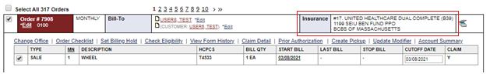

1. Primary Insurance in Order and Insurance name will be same.
2. Accept the alert

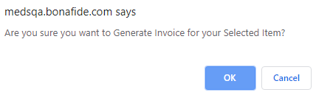

1. Wait for invoice generation

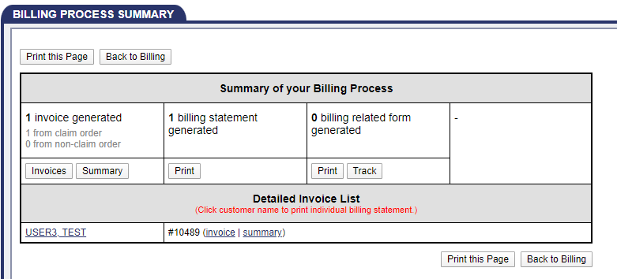

1. Click on “Invoices” to download the invoice.

Please check the below invoice for reference.

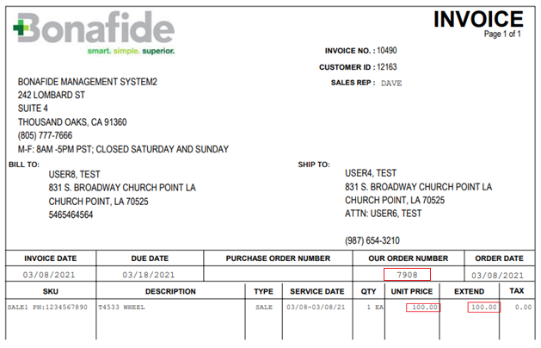

1. Now compare the order amount and invoice amount , both should be equal.